**The Economics Behind the Gender Wage Gap in the United States**

Nick Przybyla

California State University, Sacramento

ECON 145

15 May 2023

**Abstract**

The gender wage gap is a widely studied issue in the U.S. labor market. While the existence of it is inarguable, the determinants and extent to which they affect the wage gap are inarguable. This research tests the hypothesis that being female results in a lower real hourly wage. Various factors contributing to the gender wage gap including, but not limited to, gender-specific wage structures, occupational and regional differences, and college degree impact are tested using fixed effect regression analysis through R. Panel data from the PSID is used to conduct this research. 33,395 observations from the United States were obtained for the years 1981 to 2011. Based on prior research and theory, the inclusion of variables for things such as tenure, college degree, and race resulted in a negative relationship between being female and real hourly earnings.

Keywords: Gender, Gender Wage Gap, Female, Wage

**Rationale**

The gender wage gap is a persistent issue that has received significant attention in the United States over the past few decades. Despite years of advocacy and legislation aimed at closing the gap, women continue to earn less than men across a wide range of occupations and industries (about 82 cents for every dollar earned by their male counterparts). Primarily, I will aim to identify causes of the gender wage gap, using my independent variables, while also identifying potential policies and interventions that can be implemented to close the gender wage gap and promote greater gender equality in the workplace.

**Literature Review**

The gender wage gap, the difference in earnings between men and women in the workforce, has been a persistent and widely studied issue in the U.S. labor market. Despite advances in gender equality, women continue to earn less than men on average. This literature review aims to explore various factors that contribute to the gender wage gap, including gender-specific wage structure, generational differences, working hours, firm-level factors, and matching mechanisms. Rotman and Mandel (2022) investigated the impact of gender-specific wage structures on the gender wage gap in the U.S. labor market. They found that gender-specific wage structures, such as occupational segregation and pay discrimination, were major factors contributing to the wage gap. The study suggested that policies aimed at reducing gender-based wage structures could help to reduce the gap. Rahman and Al-Hasan (2022) studied the reverse gender wage gap in Bangladesh, which refers to the phenomenon where women earn more than men in certain occupations. The authors found that the reverse gap was mainly due to differences in educational attainment and experience levels between genders, rather than discrimination or gender-specific wage structures. Roche (2017) compared the gender wage gap between young workers born in the 1960s and the 1980s in the U.S. labor market. The study found that the gender wage gap had decreased over time, but remained persistent. The author suggested that differences in work experience, occupation, and education between genders may account for the remaining gap. Denning et al. (2021) explored the impact of working hours on the gender wage gap in the U.S. labor market. They found that differences in working hours between men and women were a significant contributor to the wage gap, especially in high-wage occupations. The study suggested policies aimed at promoting work-life balance and flexible work arrangements. Masso et al. (2022) investigated the role of firms in the gender wage gap in Estonia. The study found that gender-based wage discrimination was more prevalent in smaller firms, and that firms with more women in higher-level positions tended to have smaller gender wage gaps. The authors suggested that policies aimed at promoting gender diversity in leadership positions could help to reduce the gap. Meara et al. (2019) conducted a matching study to examine the gender pay gap in the U.S. labor market. They found that differences in characteristics such as occupation, education, and experience between men and women accounted for a significant portion of the gap, but that there was still evidence of discrimination against women. The study suggested that policies aimed at reducing discrimination and promoting equal opportunities could help to reduce the gap. Männasoo (2022) examined the impact of working hours on the gender wage gap using data from the American Working Conditions Survey. The study found that differences in working hours between men and women were a major contributor to the gap, especially in low-wage occupations. The author suggested that policies aimed at promoting work-life balance and reducing the stigma around flexible work arrangements could help to reduce the gap.

The literature reviewed in this paper covers a range of topics related to the gender wage gap in the U.S. labor market. While each article focuses on a different aspect of the issue, there are some common themes and findings that emerge when comparing the studies. Firstly, many of the studies reviewed suggest that the gender wage gap persists in the U.S. labor market, despite progress that has been made in recent years. The studies also suggest that the gap is influenced by a variety of factors, including gender-specific wage structures, working hours, generational differences, and firm-level factors.. Secondly, the studies reviewed suggest that policies aimed at reducing gender-based wage discrimination and promoting equal opportunities for men and women could help to reduce the gap. For example, policies such as pay transparency, anti-discrimination laws, and affirmative action programs could help to reduce the impact of gender bias on wages. Thirdly, several studies reviewed suggest that differences in working hours between men and women play a significant role in the gender wage gap. The studies suggest that policies aimed at promoting work-life balance and reducing the stigma around flexible work arrangements could help to reduce the impact of differences in working hours on the gender wage gap.

The authors of the articles reviewed in this literature review each faced their own unique difficulties during their research. Some of these difficulties included defining and measuring variables, explaining and interpreting certain phenomena, accounting for various differences, and quantifying discrimination. Quantifying discrimination seemed to be, by far, the most challenging issue to tackle. Another large limitation noted by some authors was the usage of cross-sectional data, which made it difficult to establish causality.

Overall, the studies reviewed suggest that the gender wage gap in the U.S. labor market is a complex issue that requires a multifaceted approach to address. By addressing the factors contributing to the gap and implementing policies aimed at promoting equal opportunities for men and women, we can work towards creating a more equitable and just labor market for all.

Overall, the literature reviewed in this paper suggests that the gender wage gap in the U.S. labor market is a complex issue that is influenced by a variety of factors, including gender-specific wage structures, working hours, generational differences, firm-level factors, and matching mechanisms. While progress has been made in reducing the gap over time, it remains persistent and more work is needed to ensure that men and women are paid equally for the same work. The studies reviewed in this paper suggest that policies aimed at reducing gender-based wage discrimination and promoting equal opportunities for men and women could help to reduce the gap. Additionally, policies aimed at promoting work-life balance and reducing the stigma around flexible work arrangements could help to reduce the impact of differences in working hours on the gender wage gap. Future research could further explore these issues and examine the impact of additional factors on the gender wage gap, such as race and ethnicity. By continuing to investigate and address the factors contributing to the gender wage gap, we can work towards creating a more equitable and just labor market for all.

The research in this paper will involve collecting data from the Panel Study of Income Dynamics (PSID), a longitudinal survey that collects data on income, employment, education, and demographic characteristics of individuals and households in the United States. The independent variables of interest include gender, years of schooling, academic degree, work experience, race, and location. My regression will assess the relationship between the independent variables and the dependent variable, real hourly wage. Control variables such as age, occupation, and industry will be included in the model to account for other factors that may influence the wage gap. The analysis will provide insight into the extent to which the independent variables contribute to the gender wage gap and inform policy interventions that can promote greater gender equality in the labor market. During this research, similar limitations were found that the actors in the aforementioned articles mentioned, the main one being quantifying discrimination. Regardless, there are easily quantifiable variables which do have a large impact on real hourly wage that will be used to research the determinants of the gender wage gap.

**Economic Theory**

Selection Bias and Human Capital Theory are the economic theories behind this research. Selection Bias exists in the hiring process due to consumer preference. An example of this would be a consumer seeking out someone more masculine for something like handiwork, which in turn leads to the employer hiring more men. This can lead to a sorting effect, which causes women to sort into lower paying jobs and men into higher paying ones. Human Capital Theory, on the other hand, suggests that the skills, knowledge, and experience that workers acquire over time contribute to their earning potential. Relating this theory to the research, women are less likely to invest in these skills that increase their earning potential, which leads to lower wages for them.

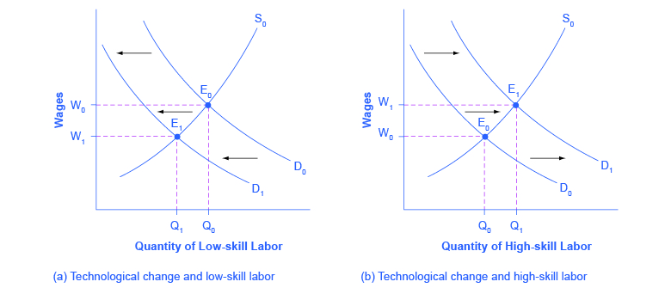

**Methodology**

Data from the Panel Study of Income Dynamics (PSID), a longitudinal survey that collects data on income; employment; education; and demographic characteristics of individuals and households in the United States, will be used for this research. The independent variables of interest include female, age, race, and tenure. My regression will assess the causal relationship between the independent variables and the dependent variable, real hourly wage. Control variables such as years of schooling, highest academic degree, and work experience will be included in the model to account for other factors that may influence the wage gap. Multiple regressions will be run where some independent variables will interact with each other. For example, additional regressions will be run that interact gender and race to check for differential wage gaps. The analysis will provide insight into the extent to which the independent variables contribute to the gender wage gap and inform policy interventions that can promote greater gender equality in the labor market.

Initial model:

$ln(Y_{it})=β_{0}+β_{1}D_{1it}+β_{2}X_{1it}+ β_{3}D_{2it}+β_{4}X_{2it}+ε_{it}$

| **Variable** | **Variable Name** | **Variable Description** |
| --- | --- | --- |
| $ln(Y_{it})$ | $ln(Y_{it})$ | Log of real hourly wage (2010 base year) |
| $D_{1it}$ | Female | 1 if female, 0 otherwise |
| $X_{1it}$ | Age | Age of individual |
| $D_{2it}$ | White | 1 if white, 0 otherwise |
| $X_{2it}$ | Tenure | Years at current employer |
| $ε_{it}$ | $ε_{it}$ | Error term |

| **Subscript** | **Subscript description** |
| --- | --- |
| i | Individual |
| t | Time |

Now I introduce controls for college degree and fixed effects for industry, occupation, and region

$ln(Y_{it})=β_{0}+β_{1}D_{1it}+β_{2}X_{1it}+ β_{3}D_{2it}+β_{4}X_{2it}+β_{5}D_{3it}+β_{6}D_{4it}+β_{7}X_{3it}+β_{8}X_{4it}+β_{9}D_{5it}+ε_{it}$

| $D_{3it}$ | BachDeg | 1 if bachelor’s, 0 otherwise |
| --- | --- | --- |
| $D_{4it}$ | AdvDeg | 1 if advanced degree, 0 otherwise |
| $X_{4it}$ | Industry | 2 digit code that represents specific industry |
| $X_{5it}$ | Occupation | 2 digit code that represents specific occupation |
| $D_{5it}$ | Region | 1 = northeast, 2 = north central, 3 = south, 4 = west |

|  | Min. | 1st Qua. | Median | Mean | 3rd Qua. | Max. |
| --- | --- | --- | --- | --- | --- | --- |
| ln(RealHrWage) | 0.701 | 2.49 | 2.89 | 2.89 | 3.28 | 6.91 |
| Female | 0.00 | 0.00 | 1.00 | 0.51 | 1.00 | 1.00 |
| White | 0.00 | 0.00 | 1.00 | 0.64 | 1.00 | 1.00 |
| BachDeg | 0.00 | 0.00 | 0.00 | 0.19 | 0.00 | 1.00 |
| AdvDeg | 0.00 | 0.00 | 0.00 | 0.09 | 0.00 | 1.00 |
| Tenure | 0.00 | 10.00 | 17.00 | 18.11 | 25.00 | 46.00 |
| TenureSq | 0.00 | 100.0 | 289.0 | 415.9 | 625.0 | 2116.0 |

**Results**

Using R, multiple regressions were run to determine the impact the chosen independent variables had on the dependent variable. To start, the dependent variable log(RealHrWage) was regressed onto the independent variables Female, Age, White, and Tenure (Model 1). These results showed an adjusted R-squared of 0.131. The p-values of all variables were statistically significant at the 95% confidence level. An unexpected sign on the coefficient of Age indicated there may have been correlation between Age and Tenure. Two more regressions were run, one excluding Age and one excluding Tenure. As expected, the signs were positive in each of the equations. Finally, the cor() command was used in R to compare the correlation between Age and Tenure. This returned a value of 0.87, confirming a high correlation between the two variables. Age was not considered in future regressions.

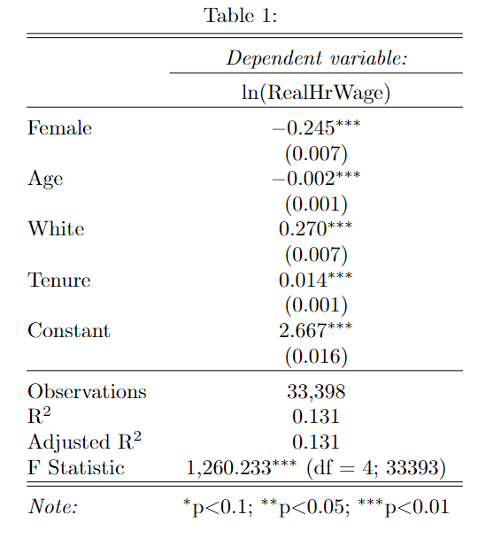

Next, Tenure-squared was considered after Tenure was plotted against the binned average of log(RealHrWage). The plot showed a non-linear relationship, shown below. An exponential rise in wages throughout someone’s tenure leads to an eventual falloff. Raises an employee gets early on are going to be much lower than the wages they get further into their tenure, then they fall back down again. This can be seen by the negative coefficient on Tenure-squared (Model 2). Dropping Age and adding Tenure-squared increased the adjusted R-squared from 0.131 to 0.146.

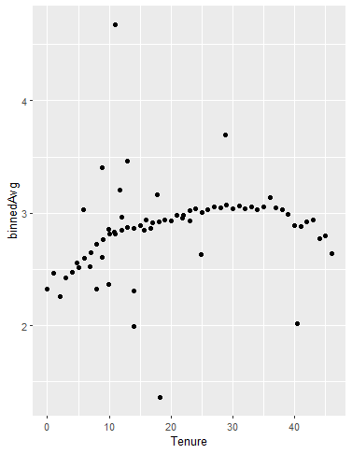

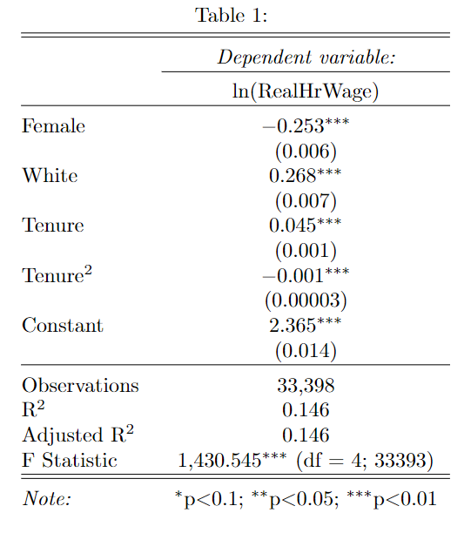

Next, 5 control variables were added: Industry, Occupation, BachDeg, AdvDeg, and Region. Industry and Occupation are 2-digit values from the PSID that represent specific areas in the workplace and help show how real hourly wage is affected across different sectors. The addition of the Industry variable alone increased the Adjusted R-squared from 0.131 to 0.200. When adding Occupation, it increased the adjusted R-squared substantially to 0.322. BachDeg has a value of 1 if someone has a Bachelor’s Degree, 0 otherwise. AdvDeg has a value of 1 if someone has an advanced degree, 0 otherwise. Lastly, Region is split into four categories: 1 for northeast, 2 for north central, 3 for south, and 4 for west. When adding all control variables, the adjusted R-squared increased to 0.387 (Model 3). This jump in adjusted R-squared shows wage discrimination depending upon where someone lives and what they do.

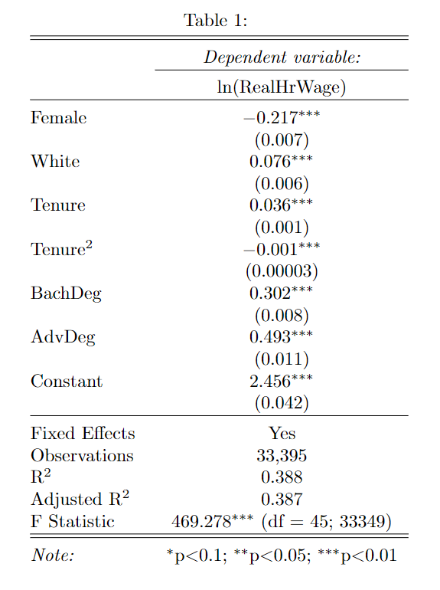

Finally, Female was interacted with White, Tenure, Tenure-squared, BachDeg, and AdvDeg. The interactions between Female:Tenure and Female:Tenure-squared were not statistically significant. If these variables were statistically significant, they would have shown the trajectory between men and women was similar, however with differing levels. Female:Tenure-squared would have less of a dropoff than Tenure-squared. However, these variables were not statistically significant. Adding these interacting terms resulted in an adjusted R-squared of 0.279 without fixed effects (Model 4).

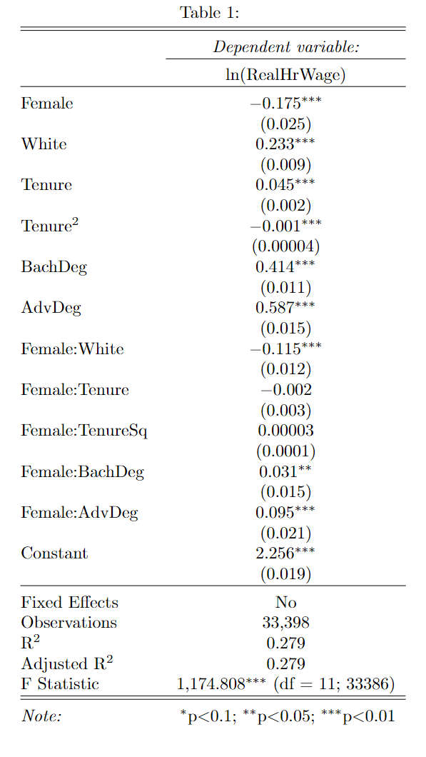

The final regression including all variables resulted in an adjusted R-squared of 0.389 (Model 5). This shows that 38.9% of changes in log(RealHrWage) can be attributed to the chosen explanatory variables. The majority of the reasoning behind the existence of the gender wage gap is attributed to what is called “the unexplained portion.” Much of this is the returns women receive from their wages, which is drastically lower than men’s returns. What can be measured, such as this regression analysis, is the “explained portion.”

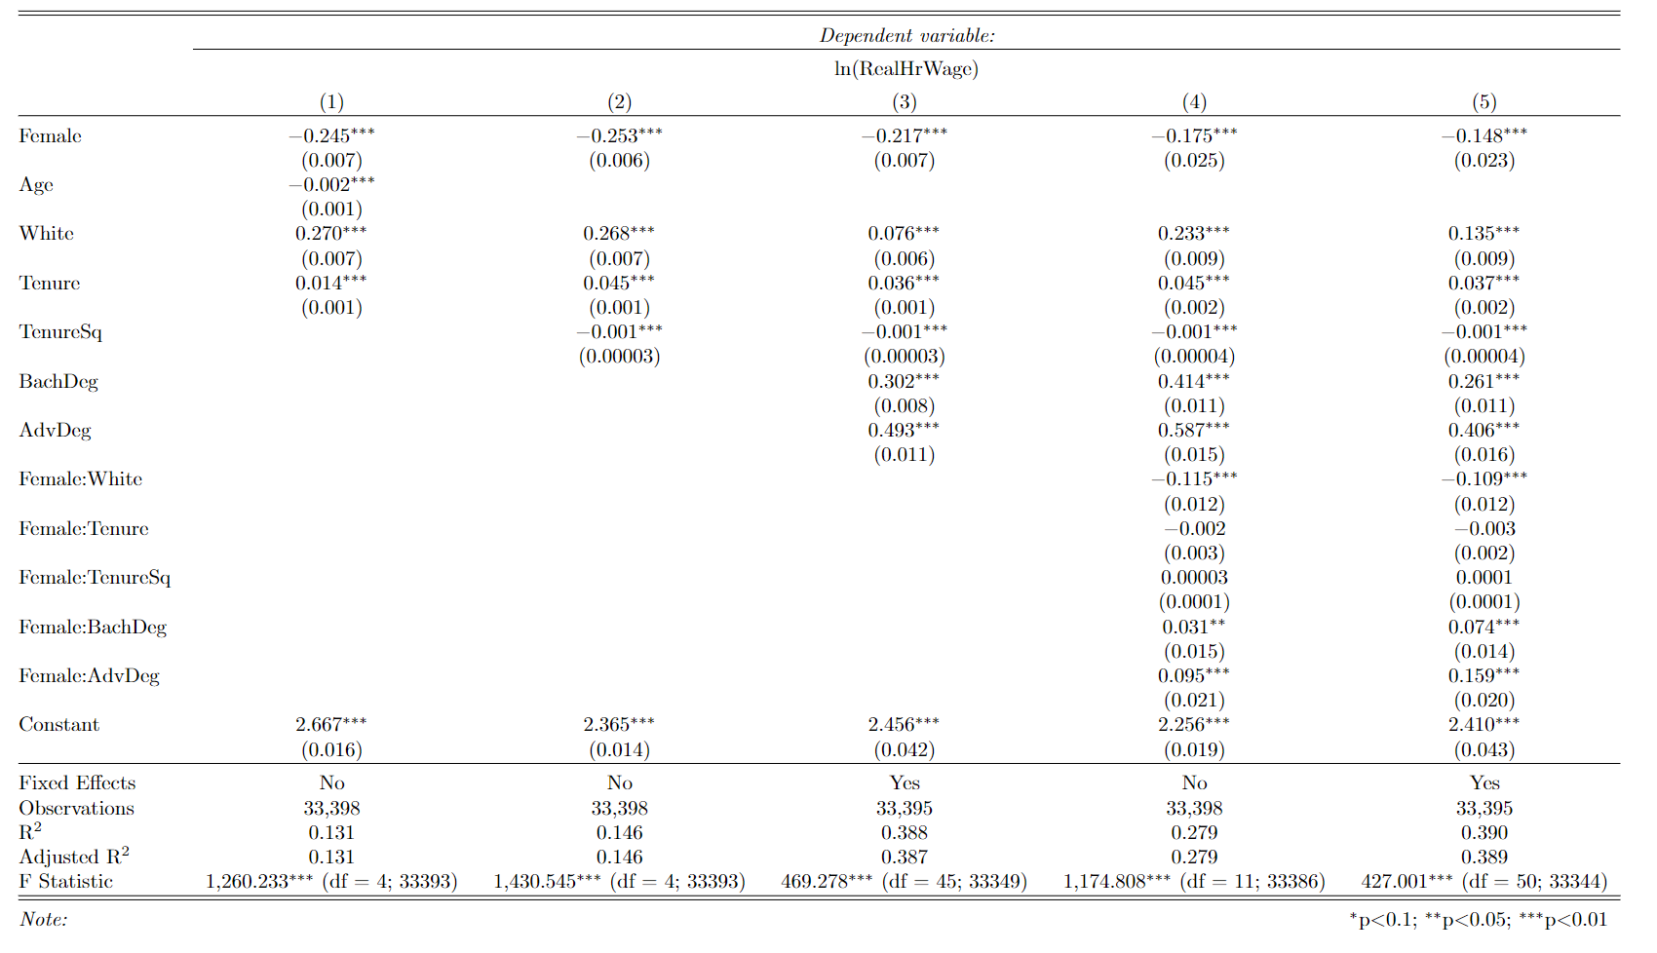

Error Tests:

*Multicollinearity*. As described above, Age and Tenure were very highly correlated. Using the cor() command in R to compare the correlation between Age and Tenure, a value of 0.87 was returned, confirming a high correlation between the two variables. Age was removed while Tenure was kept. Using the vif() function to determine the variation inflation factor, no other multicollinearity was found.

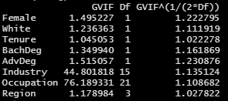

*Autocorrelation*. Using the Durbin-Watson Test, a D-W Statistic of 2.02 was returned, showing almost no autocorrelation.



*Heteroskedasticity*. First, the residuals from the regression equation were plotted against the Tenure variable which showed no signs of heteroskedasticity.

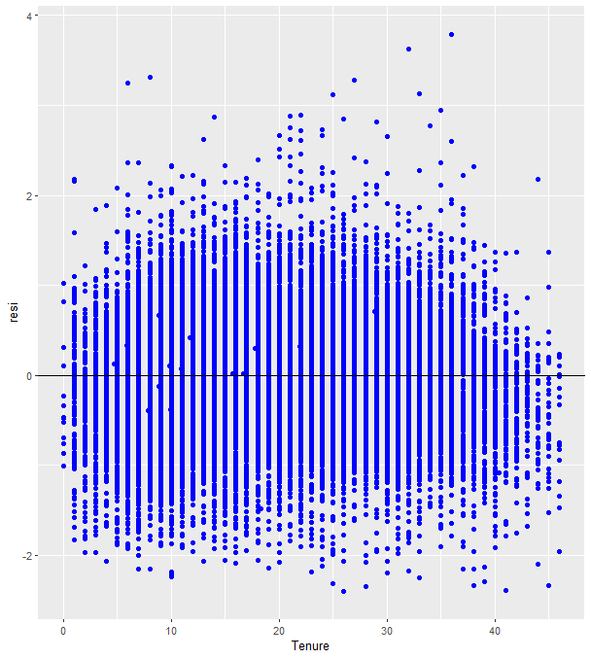

In addition to the plot, the Breusch-Pagan Test was used, which resulted in a p-value of 2.2e-16. This is much less than 0.05, so the null was rejected, meaning there was not enough evidence to show that heteroskedasticity was present.

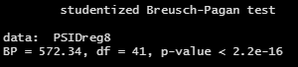

**Conclusion**

This study began with the hypothesis that being female results in a lower real hourly wage. Panel data was collected from the PSID which resulted in 33,395 observations from the United States between 1981 and 2011. After adding control variables and interacting terms, the final regression showed that we failed to reject the null hypothesis, meaning we could not reject that being female does result in a lower real hourly wage. Specifically, being female, ceteris paribus, was shown to decrease real hourly wage by 0.148-percent for minority women, and 0.122-percent for white women. An adjusted R-squared of 0.389 showed that 38.9-percent of changes in real hourly wage could be explained by the included independent variables. With the p-value of the F Statistic being much less than 0.05, this model was deemed statistically significant at the 95-percent confidence level, with all but two variables: an interaction between Female and Tenure and an interaction Female and Tenure-squared, also being statistically significant. When looking at the control variables, all but Tenure-squared and an interaction between Female and White showed decreases in real hourly wage. The negative coefficient on Tenure-squared is explained by a non-linear relationship between Tenure and the dependent variable. Once a certain level of tenure is reached, your earnings actually start to decrease. As for the interacting term, someone who is both white and female, it can be looked at as a penalty for being female. The White variable on its own is positive, meaning being white results in an increase in real hourly wage. However, the penalty for being female outweighs the benefit for being white, which inevitably results in a decrease in real hourly wage.

The main limitation in this research was not having variables for mother’s income, mother’s educational attainment, and other races besides white. I was only able to conclude that white women specifically made less than their male counterparts, but not other individual races. The Female coefficient does cover minority women as a whole, but I would consider the lack of coefficient for individual races, other than white, as a limitation in my research. The variables on the PSID did cause a bit of confusion, as many were either nonexistent, or renamed throughout the years. Seeing differential wage gaps based on different characteristics, including those who consider themselves to be non-binary, would have been very interesting, and is something I plan to look into as I continue this research in the future.

Many policy implications can help to shrink the gender wage gap. One effective way to reduce the gender wage gap is to promote pay transparency, which involves disclosing salaries for all employees in an organization. This can help ensure that women are paid fairly compared to their male counterparts. This has been increasing in popularity recently, which is very good to see. Governments can also pass laws mandating equal pay for equal work. These laws can also require companies to regularly report their gender pay gap data and take steps to address any disparities. Another important policy consideration is to ensure that recruitment and promotion processes are gender-neutral. This can involve eliminating unconscious biases in job descriptions, interviewing practices, and performance evaluations. This is something that would be very difficult to ensure happens without audits or some sort of regulation. Many people have implicit biases that they do not even realize, so training would be crucial to help them tackle this.

Another problem is many women are held back from advancing in their careers due to caregiving responsibilities. Oftentimes, many women lose out on promotion opportunities because of childbearing. Many employers will even consider this during the interview process and discussions about receiving a raise. Therefore, policies that promote flexible work arrangements, such as telecommuting, job-sharing, and flexible scheduling can help women balance their work and family responsibilities. To go along with this, paid family leave policies can also help reduce the gender wage gap. These policies provide employees with paid time off to care for a new child or a sick family member without sacrificing their income or career prospects. Also, accessible and affordable childcare can help women balance their caregiving responsibilities with their work. Governments can subsidize childcare costs and provide tax credits to employers who offer on-site childcare facilities.

**References**

Denning, J. T., Jacob, B. A., Lefgren, L. J., & vom Lehn, C. (2021). The return to hours worked

within and across occupations: Implications for the gender wage gap. *ILR Review*, *75*(5),

1321–1347. https://doi.org/10.1177/00197939211045376

Männasoo, K. (2022). Working Hours and gender wage differentials: Evidence from the

American Working Conditions Survey. *Labour Economics*, 76, 102148.

https://doi.org/10.1016/j.labeco.2022.102148

Masso, J., Meriküll, J., & Vahter, P. (2022). The role of firms in the gender wage gap. *Journal of*

*Comparative Economics*, *50*(2), 454–473. https://doi.org/10.1016/j.jce.2021.10.001

Meara, K., Pastore, F., &amp; Webster, A. (2019). The gender pay gap in the USA: A matching

study. *Journal of Population Economics*, 33(1), 271–305.

https://doi.org/10.1007/s00148-019-00743-8

Rahman, M., & Al-Hasan, M. (2022). The reverse gender wage gap in Bangladesh:

Demystifying the counterintuitive. *The Indian Journal of Labour Economics*, 65(4),

929–950. https://doi.org/10.1007/s41027-022-00402-9

Roche, K. (2017). Millennials and the gender wage gap in the U.S.: A cross-cohort comparison

of young workers born in the 1960s and the 1980s. *Atlantic Economic Journal*, 45(3),

333–350. https://doi.org/10.1007/s11293-017-9546-6

Rotman, A., & Mandel, H. (2022). Gender-specific wage structure and the gender wage gap in

the U.S. labor market. *Social Indicators Research*, *165*(2), 585–606.

https://doi.org/10.1007/s11205-022-03030-4